- Create a file with .txt extension (/home/demo.txt). Change the permission set of that file, so that any user can read it, group can read/write & owner can read/write/execute it.

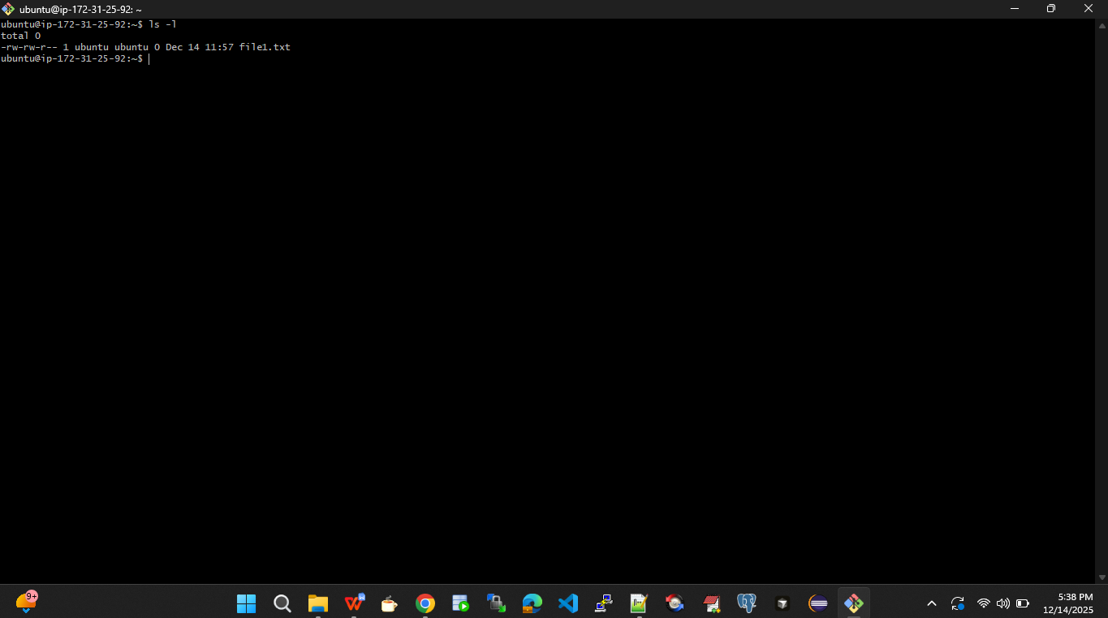
Changed the file permission to -rwxrw-r-- for the file1.txt

